CSIT314 Software Development Methodologies - Group Project

Sprint 4 - US34: Search saved list
Interior Design Platform - Customer
All diagrams were drawn in draw.io. Open "US34 Search saved list.drawio" in this folder to edit them - each diagram is its own page in that file. The exported images are in the "diagrams" folder.

Assumptions
- The system is the Interior Design Platform from the project specification. Sprint 4 covers the Interior Designer's past IDP stories (US25 - US29) and the Customer's saved list stories (US33 - US35).
- We follow B-C-E: the actor only talks to the boundary (page), the boundary only talks to the controller, and the controller works with the entity classes. There is one controller per use case.
- Who checks what: the boundary checks all the input (required fields, lengths, formats, e.g. not suspending your own profile) and trims spaces, then passes an entity object on. The controller just calls the entity and returns the result. The entity checks for duplicates and the database state (e.g. name already used, only Active rows are changed), then saves. In US34 the page trims the spaces from the keyword and checks it is at most 100 characters (an empty keyword is allowed and shows the whole saved list). SearchSavedListController.searchSavedList(customerId, keyword) just calls SavedIDP.searchSavedRecords(customerId, keyword) and returns the list - no checks and no trimming. The entity only looks in this customer's saved list and only returns IDPs customers can still see.
- Being logged in as a Customer (UC30) is the precondition, so the page and the diagrams don't check the customer again (no CustomerLoginController). customerLoginRequired in app.py only sends someone with no session to /customer/login. The customerId is always session["userId"], never a value from the page.
- The search bar is on the Saved IDPs page (US35). The page class SavedListPage is shared by US35 and US34, but each use case has its own controller.
- The keyword matches the title, description, location or category name of the IDPs in the Customer's own saved list. Capitals are ignored. Results are most recently saved first.
- An empty keyword (or only spaces) shows the whole saved list. A keyword longer than 100 characters shows "The keyword can be at most 100 characters" (HTTP 400) and the controller isn't called.
- Saved IDPs that were deleted or whose category was suspended are left out of the results.
- No matches → "No saved IDPs match your search" (MSG_NO_RESULTS), with the keyword kept in the box. Clear goes back to the whole saved list (US35). Searching never changes any data.

1. User story
Story ID | US34
User story | As a customer, I want to search my saved list so that I can find an IDP I saved earlier.
Actor | Customer
Priority | Medium
Story points (estimate) | 2
Acceptance criteria | 1. Given I am logged in as a customer and on Saved IDPs, when I type a keyword and click "Search", then I see the IDPs in my saved list whose title, description, location or category contains it (capitals and spaces around the keyword are ignored).  2. Only my own saved IDPs that are still available are searched, and the keyword stays in the search box.  3. Given I leave the keyword empty, then I see my whole saved list; "Clear" also goes back to the whole list.  4. Given nothing matches, I see "No saved IDPs match your search".  5. Given the keyword is longer than 100 characters, I see "The keyword can be at most 100 characters" and no search is done.  6. Given I am not logged in, when I open the search, then I am sent to the customer login page.
Tasks | #193 Draw Use Case Diagram and Write Use Case Description  #201 Draw BCE and Sequence Class Diagram  #209 Implement a search function to allow customers to find projects within their saved list.  #253 Design Wireframe  #256 Write and Execute Test Cases

2. Use case diagram
The user story becomes one use case, UC34 Search saved list. The Customer is the only actor. Being logged in (UC30) is the precondition; the search bar is on the Saved IDPs page (UC35), and View on a result opens UC32 View IDP.
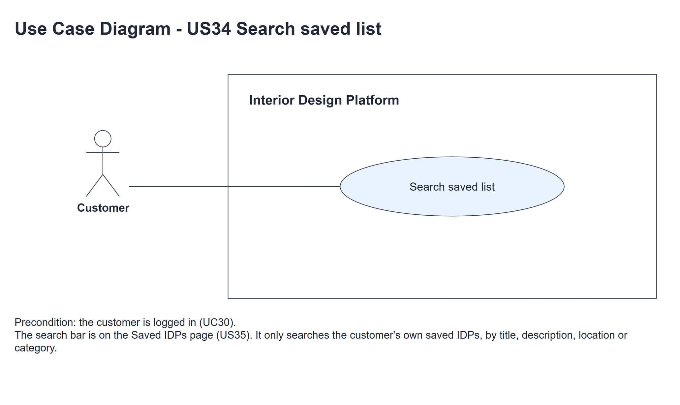
Figure 1: Use case diagram for US34 Search saved list

3. Use case description
Use case | UC34 Search saved list
Actor | Customer
Brief description | The Customer searches their own saved list to find an IDP they saved earlier.
User story | US34: As a customer, I want to search my saved list so that I can find an IDP I saved earlier.
Preconditions | The Customer is logged in (UC30) and is on the Saved IDPs page (UC35).
Trigger | The Customer types a keyword in the search bar on Saved IDPs and clicks "Search".
Basic flow | 1. The Customer types a keyword and clicks "Search".  2. The system trims the spaces from the keyword and checks it is at most 100 characters.  3. The system searches the Customer's saved list for the IDPs whose title, description, location or category name contains the keyword, leaving out IDPs that are no longer available, most recently saved first.  4. The system shows the matching saved IDPs, each with View, and keeps the keyword in the search box.
Alternative flows | 2a. The keyword is longer than 100 characters: the system shows "The keyword can be at most 100 characters" (HTTP 400) and doesn't search.  2b. The keyword is empty (or only spaces): the search matches every IDP in the saved list.  4a. Nothing matches: the system shows "No saved IDPs match your search" and keeps the keyword in the box.
Postconditions | The matching saved IDPs (or a message) are shown. No data is changed.

4. Wireframes
The wireframes were drawn in draw.io. They are low-fidelity: they show the layout and the flow, not the final colours. They follow customerBase.html, savedList.html and static/style.css.

4a - Search results
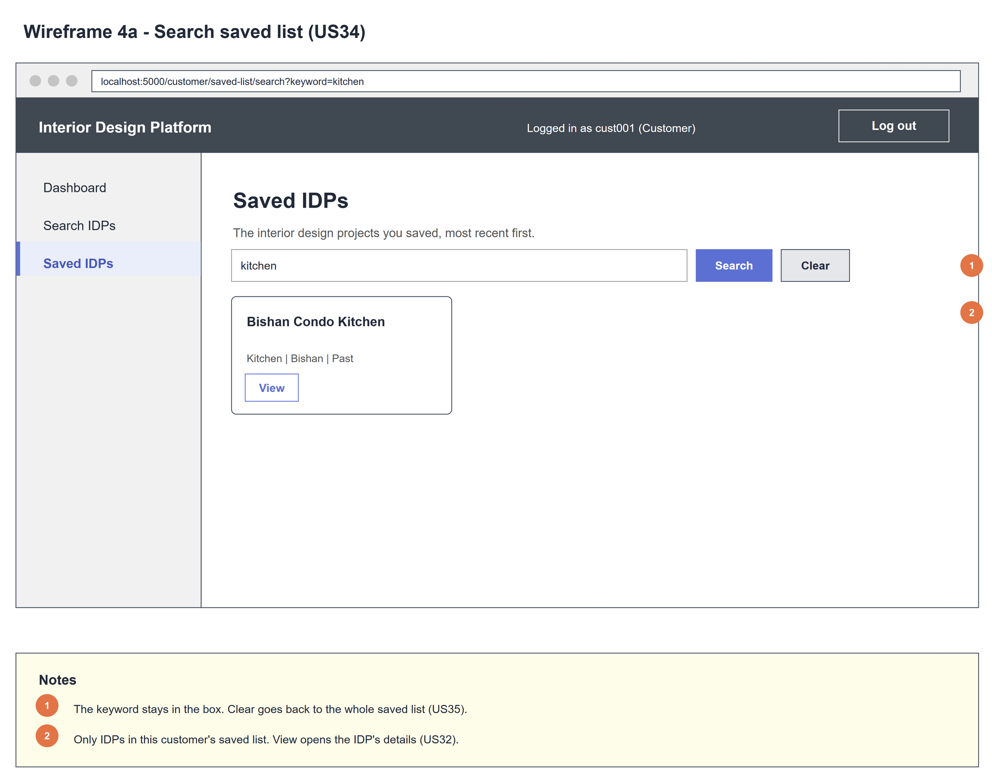
Figure 2: Wireframe 4a - Search results (US34)

4b - No matching saved IDPs
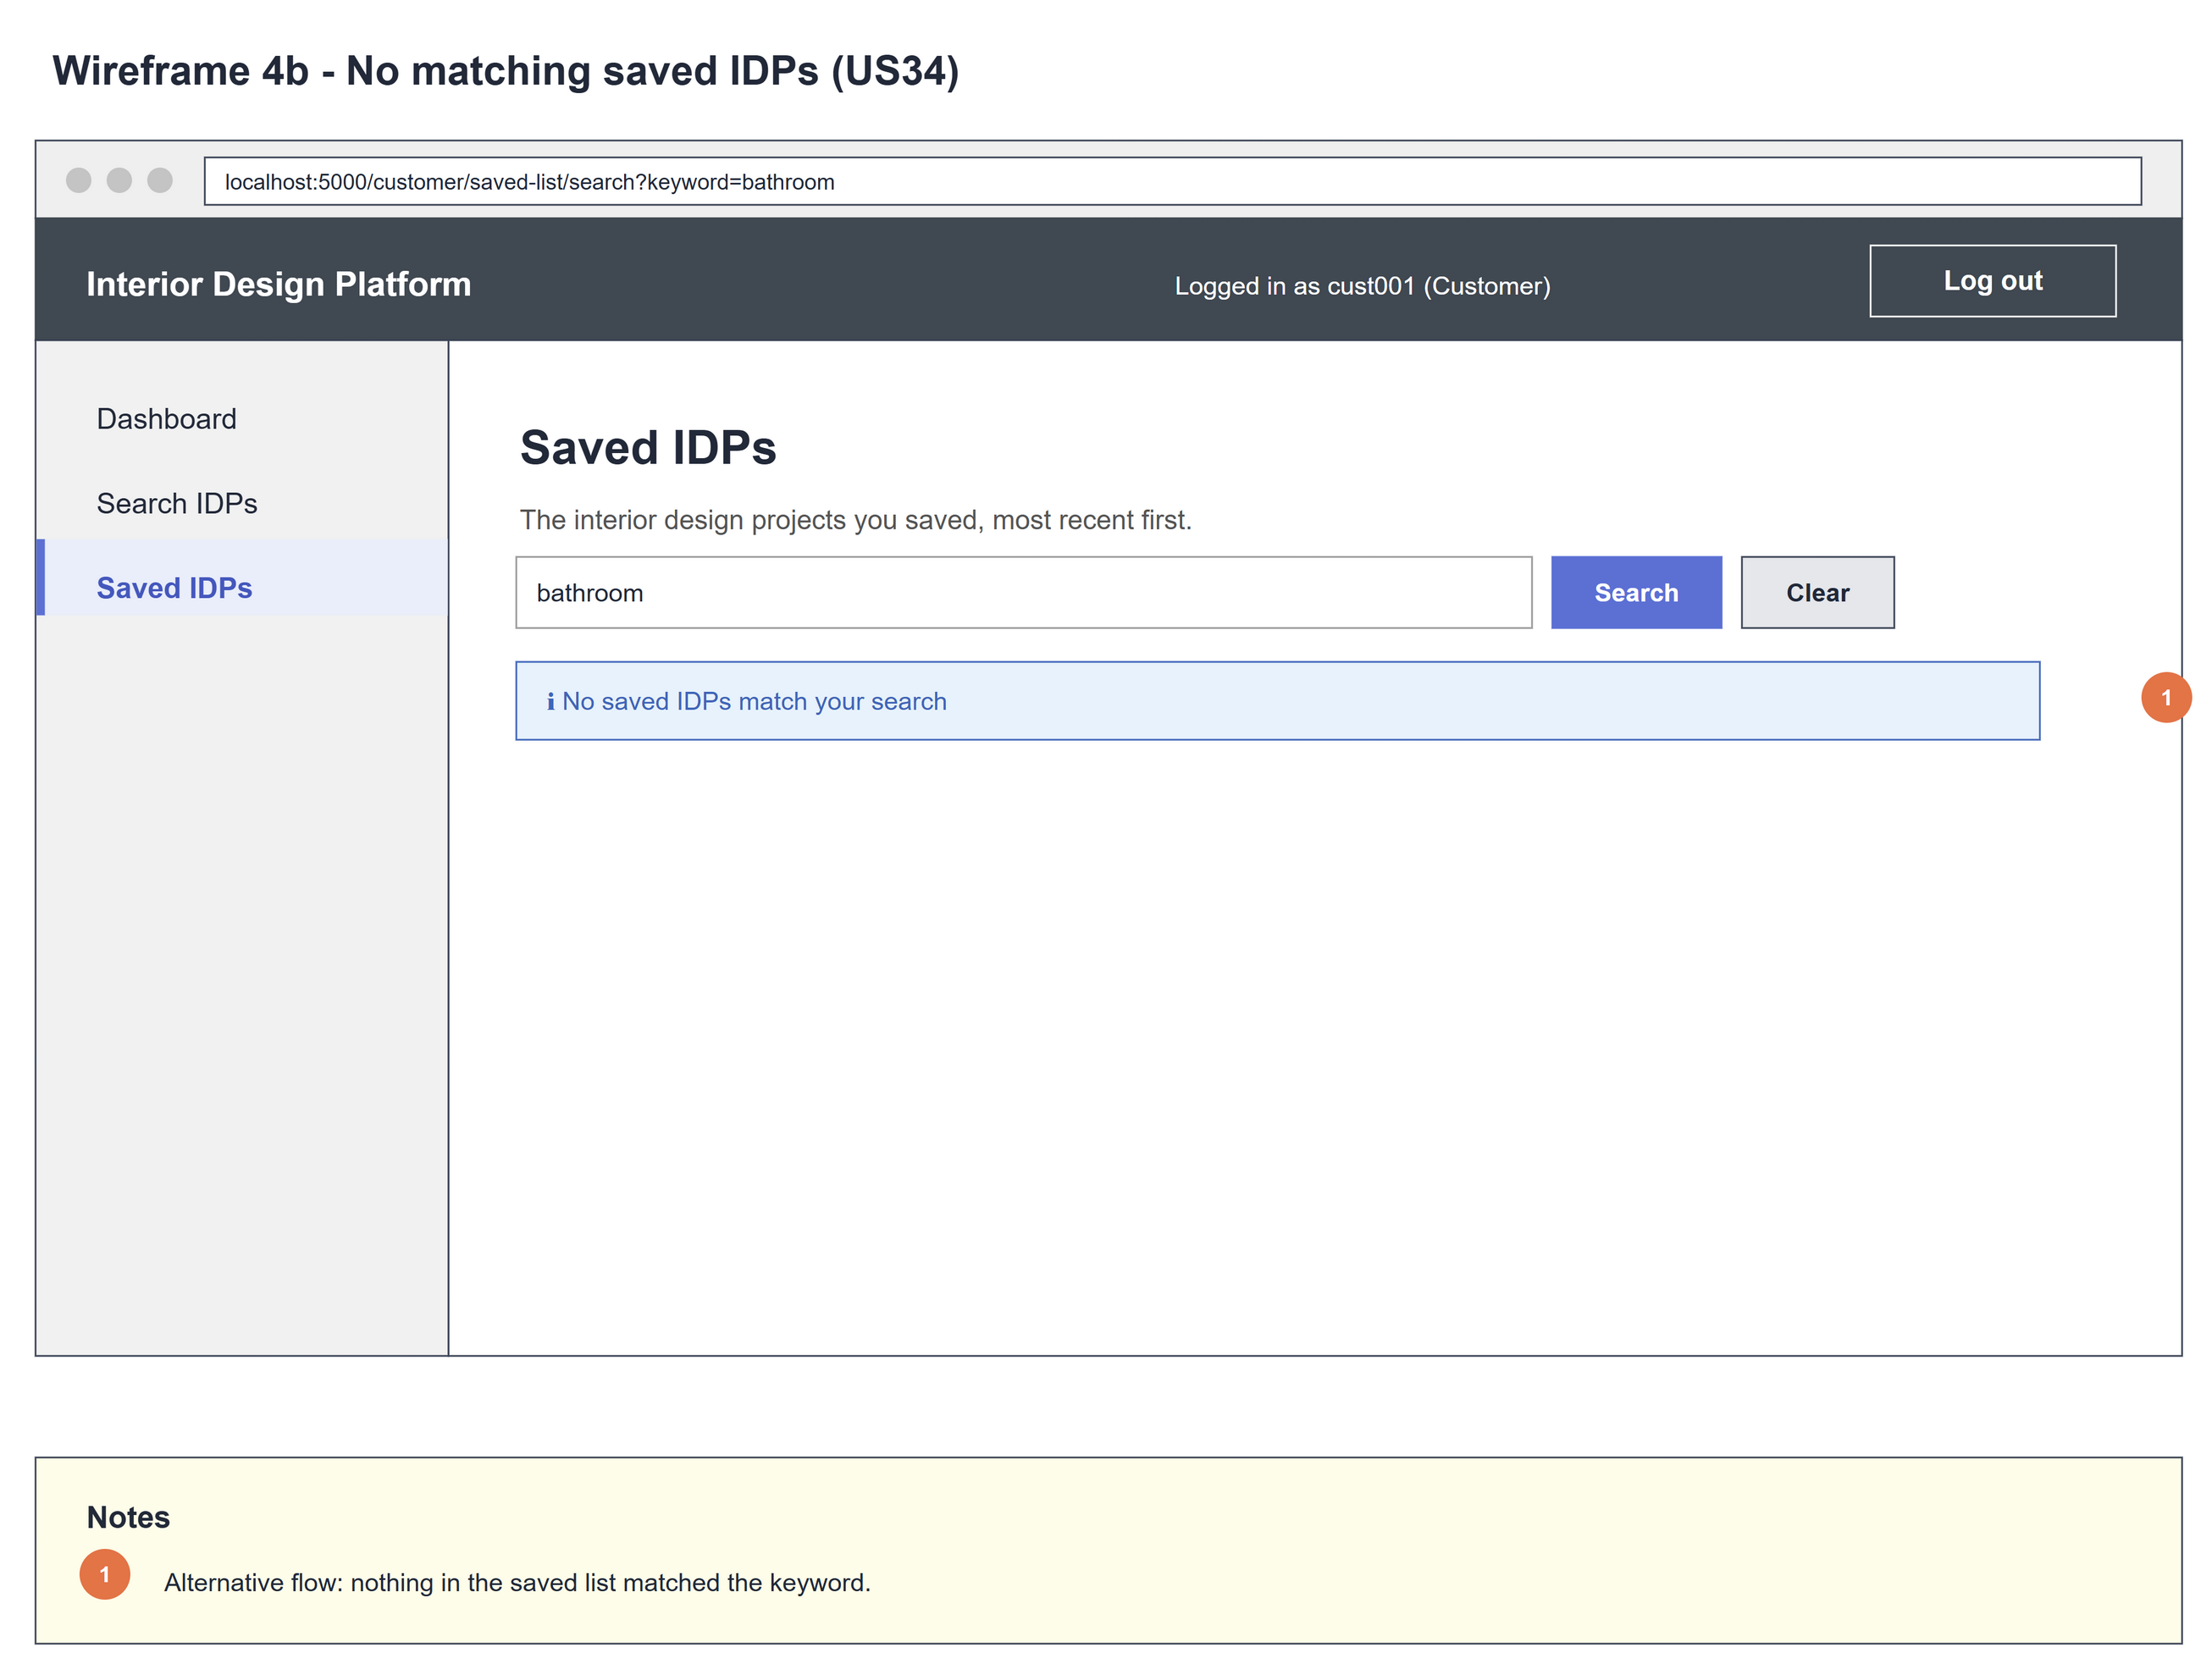
Figure 3: Wireframe 4b - No results (US34)

5. B-C-E class diagram
The solid line means the boundary calls the controller. The dashed line means the controller uses the entity class. Only the operations needed for this use case are shown, with the same names as the code.
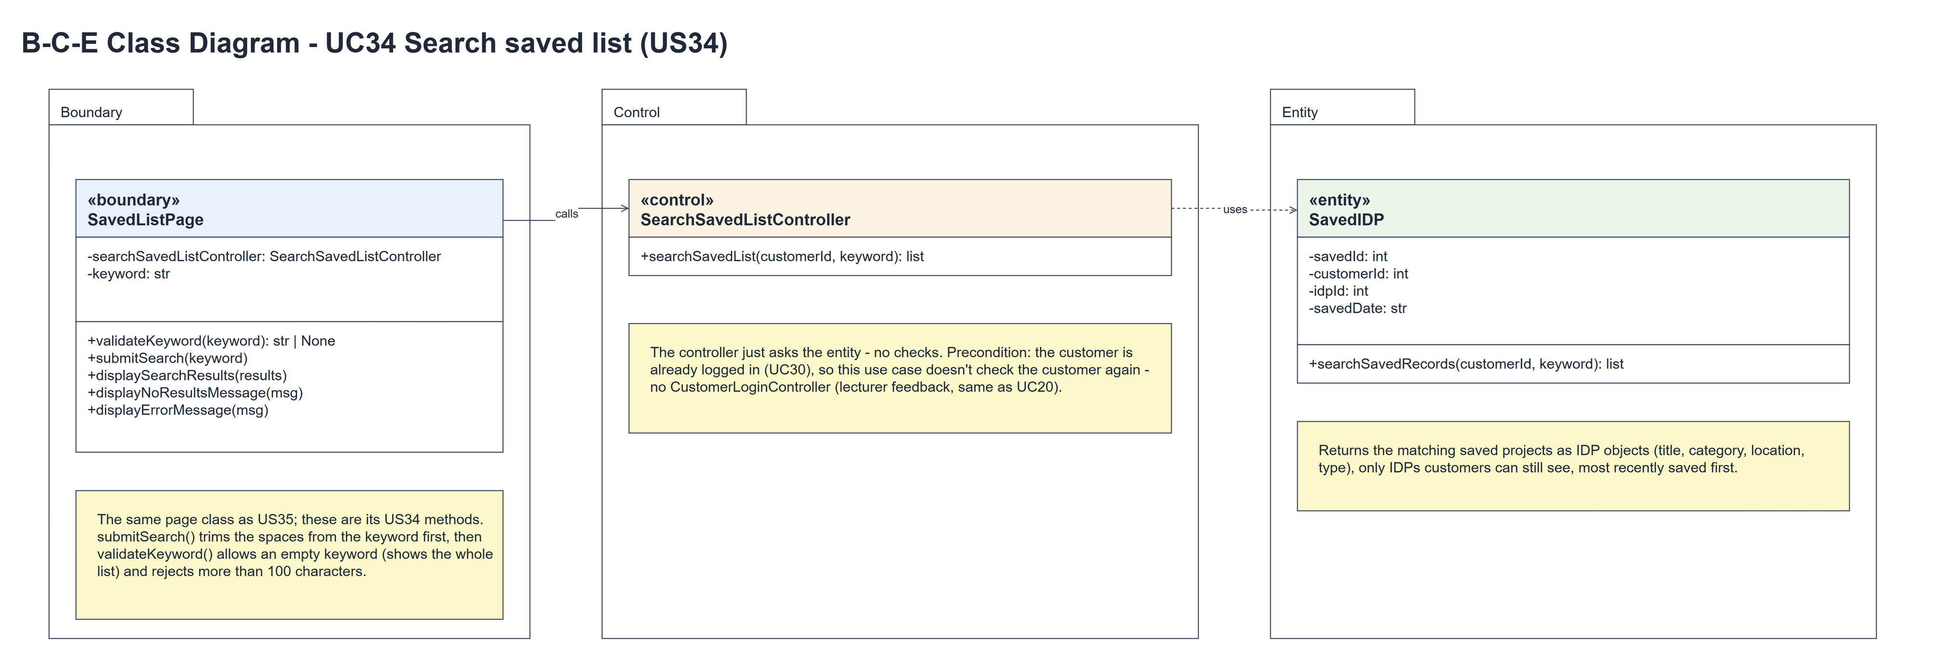
Figure 4: B-C-E class diagram for US34 Search saved list
Layer | Class | What it does
Boundary | SavedListPage | The Saved IDPs page (shared with US35). submitSearch(keyword) trims the keyword and calls validateKeyword(keyword) (at most 100 characters; empty is allowed). Valid → searchSavedList(session userId, keyword), then displaySearchResults(results) or displayNoResultsMessage(MSG_NO_RESULTS). Too long → displayErrorMessage(MSG_KEYWORD_TOO_LONG) (HTTP 400) and the controller isn't called.
Control | SearchSavedListController | Controller for UC34. searchSavedList(customerId, keyword) just calls SavedIDP.searchSavedRecords(customerId, keyword) and returns the list - no checks.
Entity | SavedIDP | The only entity. searchSavedRecords(customerId, keyword) returns this customer's saved IDPs (as IDP objects with categoryName) whose title, description, location or category name contains the keyword - only Active IDPs in Active categories, most recently saved first.

6. Sequence diagram
The sequence diagram follows UC34. The page trims the keyword and checks it (step 2). The outer alt shows the two cases: a valid keyword, where the controller just calls the entity (steps 3-6) and the inner alt shows the matching IDPs or the no-results message (alternative flow 4a); and a keyword that is too long, where the controller is never called (alternative flow 2a).
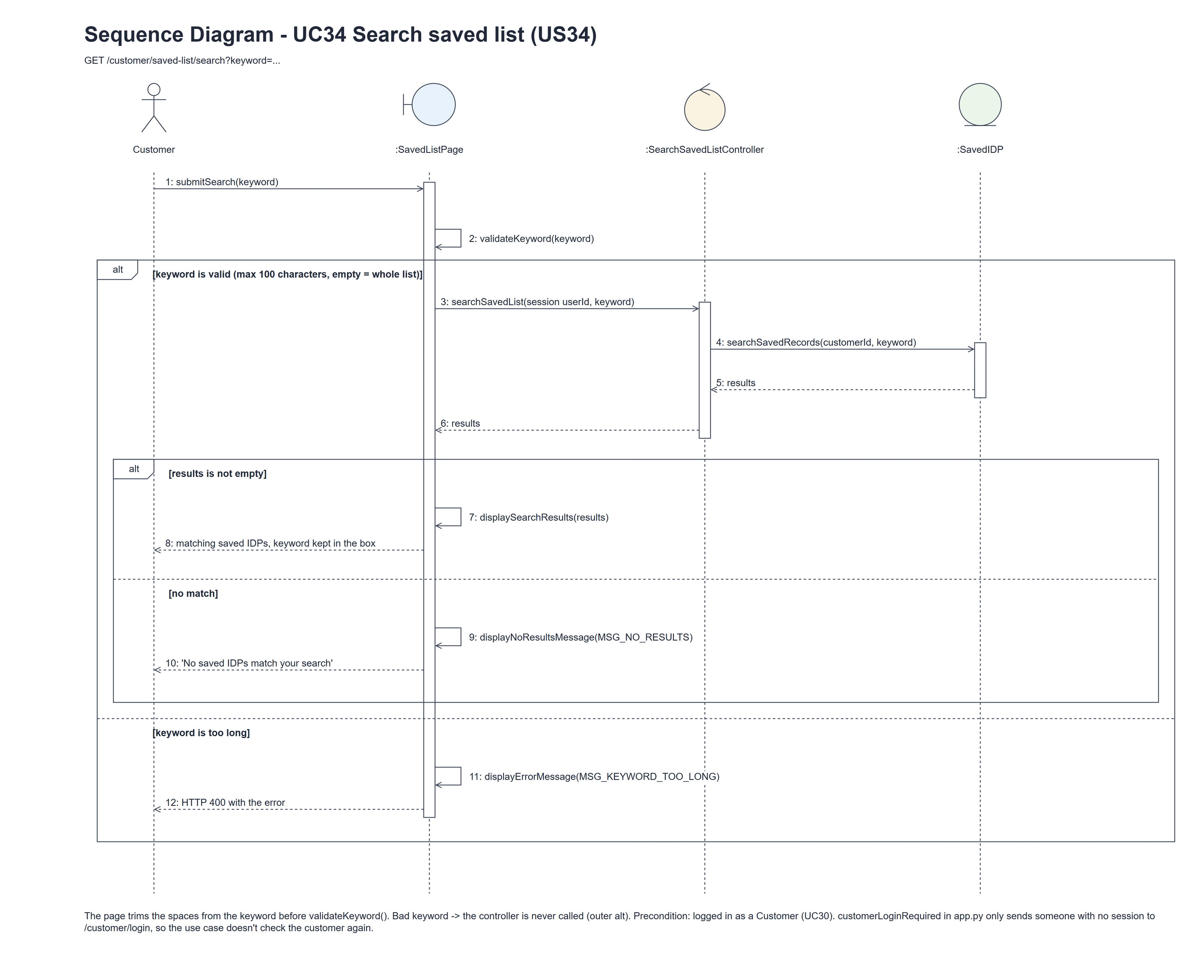
Figure 5: Sequence diagram for UC34 Search saved list

7. Test cases
Test data used below (same as the test file): an interior designer with IDPs in the Kitchen and Bedroom categories, the customer cust001 / Cust@123 with two saved IDPs (Modern Kitchen, Cosy Loft) and one IDP that is not saved, and a second customer. Tests use an isolated database.

7a. System test cases (black box)
Equivalence partitioning and boundary value analysis were used to pick the test data. Fill in "Actual result" and "Pass/Fail" after running each test.
Test ID | Scenario | Prerequisites | Test steps | Test data | Expected result | Actual result | Pass / Fail
TC34.1 | Search by title | Two IDPs saved. | Type a keyword; click Search. | kitchen | Only the matching saved IDP; the keyword stays in the box.
TC34.2 | Category / location | Saved IDPs in two categories. | Search each field. | Bedroom; a location | The matching saved IDPs only.
TC34.3 | Capitals and spaces | A matching IDP is saved. | Search a padded upper-case keyword. | " KITCHEN " | Same results as "kitchen"; the box shows the trimmed keyword.
TC34.4 | Empty keyword / Clear | Two IDPs saved. | Search with an empty keyword; click Clear. | Empty; spaces | The whole saved list.
TC34.5 | Only my saved list | An IDP matches but isn't saved; another customer has a saved list. | Search a matching term. | Not Saved Kitchen | Only IDPs in my own saved list are shown.
TC34.6 | No matches | IDPs saved. | Search an unknown term. | zzz | "No saved IDPs match your search"; the keyword stays in the box.
TC34.7 | Keyword too long | Customer logged in. | Search a 101-character keyword. | 101 x "a" | HTTP 400 "The keyword can be at most 100 characters".
TC34.8 | Hidden IDP | A saved IDP was deleted or its category suspended. | Search for it. | Suspended IDP | Not shown.
TC34.9 | Not logged in | Signed out. | Open /customer/saved-list/search?keyword=x. | No session | Sent to the customer login page.

7b. Unit test cases (for TDD)
These are written before the code (test-driven development) and run automatically in the CI pipeline. They cover normal inputs, abnormal inputs and boundary values. Each one matches a test function in tests/test_us34_searchSavedList.py (UT34.1 is test_ut34_1_...). Controller means SearchSavedListController; Boundary means SavedListPage. "Pass" is from the pytest run on 10 November 2026.
Test ID | Class and method | Input / setup | Expected output | Type | Pass / Fail
UT34.1 | SavedIDP.searchSavedRecords() | "KITCHEN"; "bedroom" (a category). | Only the matching IDP in the saved list, capitals ignored; the category name matches too. | Normal | Pass
UT34.2 | SavedIDP.searchSavedRecords() | Another customer with nothing saved searches "kitchen". | Empty list - other customers' saved lists aren't searched. | Abnormal | Pass
UT34.3 | SavedIDP.searchSavedRecords() | ""; "zzz" | "" gives the whole saved list; "zzz" gives an empty list. | Boundary | Pass
UT34.4 | Controller.searchSavedList() | "loft" | The entity's list is returned unchanged (Cosy Loft). | Normal | Pass
UT34.5 | Boundary.validateKeyword() | ""; 101 characters | None for ""; MSG_KEYWORD_TOO_LONG for 101 characters. | Boundary | Pass
UT34.6 | Boundary.submitSearch() (GET) | keyword=kitchen | Only Modern Kitchen - not the other saved IDP or the unsaved one; value="kitchen" kept in the box. | Normal | Pass
UT34.7 | Boundary.submitSearch() (GET) | keyword=zzz | MSG_NO_RESULTS shown. | Abnormal | Pass
UT34.8 | Boundary.submitSearch() (GET) | 101-character keyword | HTTP 400 with MSG_KEYWORD_TOO_LONG. | Boundary | Pass
UT34.9 | customerLoginRequired (app.py) | GET search, not logged in. | Redirects to /customer/login. | Abnormal | Pass
UT34.10 | Boundary.submitSearch() | " kitchen " with SearchSavedListController stubbed. | The page trims it: the controller gets (customerId, "kitchen") and the box shows "kitchen". | Boundary | Pass
UT34.11 | SavedIDP.searchSavedRecords(customerId, keyword) | cust001 also saved "100% Recycled_Wood Bath" (Bathroom); keywords "%", "_" and "k%n" | [100% Recycled_Wood Bath] for "%" and for "_"; [] for "k%n" - % and _ are plain text, not wildcards | Abnormal | Pass

